

Dr. John, Caldwell inc.

2023-11-11

Dr. Caldwell

2532 Sanders Brook Apt. 286, Darylmouth, RI 36828

Phone: 2596792559

Fax: 4513615706

**Re:** Kristen, Roberts

**PHN:** 6923331039

**Birthdate:** 29-Aug-1948

**Address:** 4723 Charles Drive, Maxburgh, ID 29149

**Patient number:** 2245853137

To Whom It May Concern:

This is a medical letter to state the above patient is pregnant with expected delivery date of 01-Mar-2025. Hoping this information is satisfactory for your requirements.

Thank you.

Sincerely,

Dr. John, Caldwell

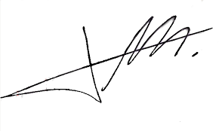

FRCS© NCMP

Clinical Assistant Professor, UBC

Department of Obstetrics and Gynecology SMH